**Literature**

Many firms and professors of IIT’s are working on it and many got success

Some of the websites names are :

1. <https://github.com/sllloyd/vaccine_predictions>

**Vaccine Pipeline Modelling**

The model takes data on existing COVID-19 vaccines in various stages of clinical trials and expert opinions as to their likely success and predicts how many vaccines will get proper regulatory approval and on what timescales. The model uses Monte Carlo techniques to randomly decide an outcome given the input paramaters.

1. <https://www.nytimes.com/interactive/2020/science/coronavirus-vaccine-tracker.html>

**Coronavirus Vaccine Tracker**

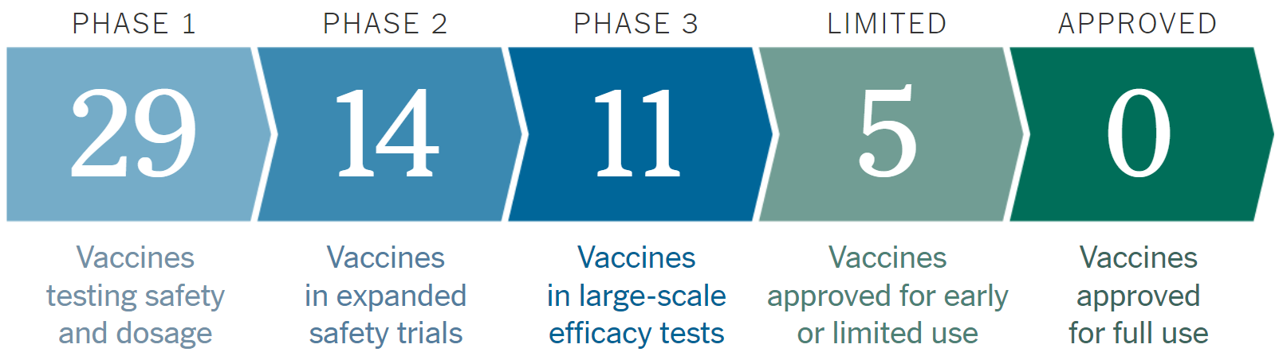

This Website gives us an statistical knowledge with details about Vaccines on Phase 1, Phase 2, Phase 3, Emergency Vaccine and approved one’s.

1. <https://www.raps.org/news-and-articles/news-articles/2020/3/covid-19-vaccine-tracker>

**COVID-19 vaccine tracker**

This website basically tells us about the Cadidate, Mechanism, Sponsor, TrialPhase and Institution. This website has almost every COVID-19 Vaccine with their details given in tabular form.

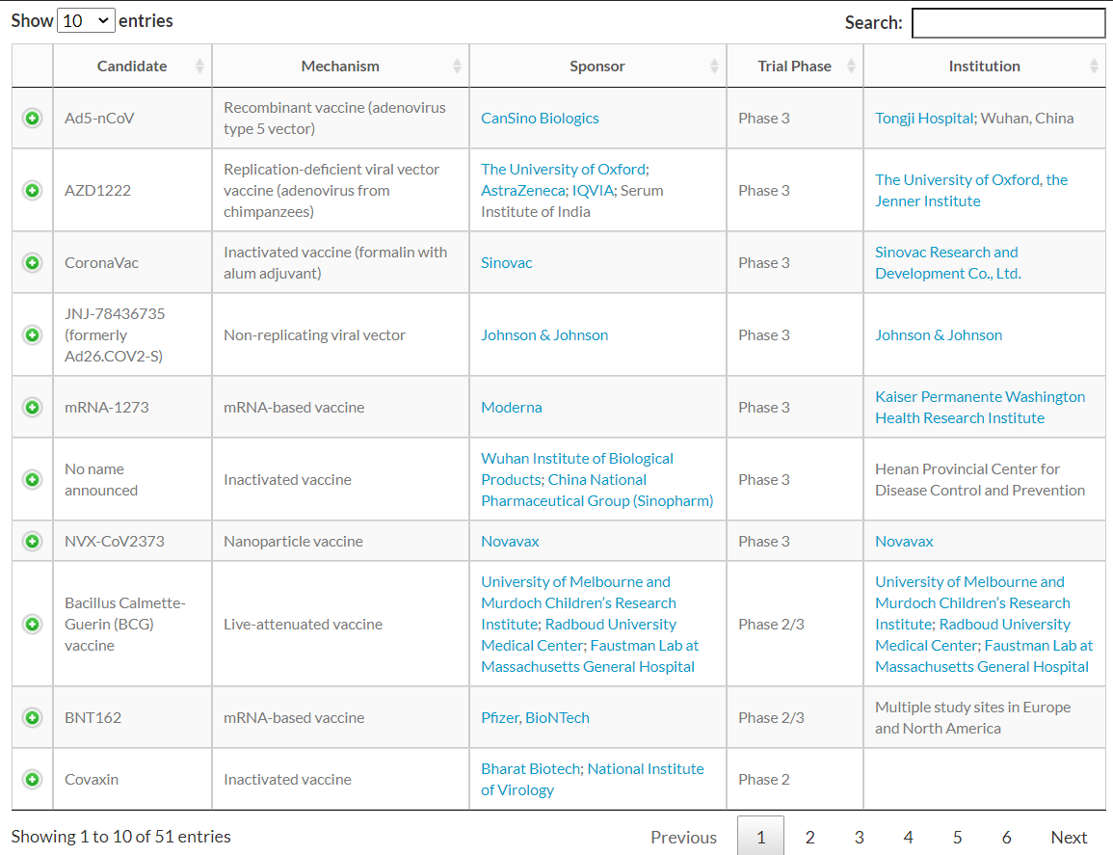

Now the question arises is how is our model different from the models already available on Internet ?

Our predictive model will take all the past data about that vaccine and will predict the possibility of its approx. manufacturing date and will also predict its failure and delay rate, there is no such app with such user interface.

Our predictive model will let the users to track on all leading pharmaceutical groups, organizations, medical research institutes, biotechnological companies like Novavax, Bharat Biotech, Moderna, Johnson and Johnson, CanSino Biologics,etc. on their progress on developing vaccine for SARS-CoV-2. Our predictive model will predict which organization will be able to produce vaccine sooner. Our model will produce outputs such as ranked list of the organizations, which will also mention vaccine name, mechanism used, sponsor of the vaccine, Trial Phase, Institution name, predicted release date, announced release date, side effects till now (if human trials have started), effectiveness of the vaccine, etc. Also our model will produce plots such as plot on progress versus time of different organizations, vaccine effectiveness versus organization names,etc.

Our model will serve as a relief to the people by giving them an option to use the model to track COVID-19 vaccine and predict its release date with high precision.